Zakeke 3d Configurator

Sitegenesis extension

-TEST CASE-

*link_zakeke*

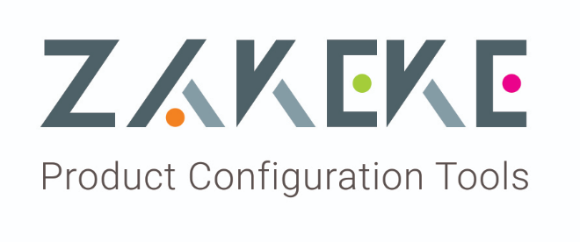



Table of Contents

Summary 4

Testing 5

# Summary

This document describes how to verify that installation and configuration of Zakeke cartridge in **Sitegenesis** platform has been made correctly.

Zakeke offers a product configurator/customizer in real-time 3D to enable customers to compose store products according to their needs and tastes.

This APP includes an extension for “Commerce Cloud” to plugs a cloud-based configurator into your web store and allows you to create configurable products and set personalization rules to offer your customers an immersive and interactive "personalize-it" experience.

# Testing

After installation and configuration of CommerceCloud environment and Zakeke platform, the client can test the extension this way.

1. Import a new product using Zakeke platform. You can find instructions at the following url: <https://zakeke.zendesk.com/hc/en-us?customizer>
2. Go to business manager. Go to Merchant tools->Product and search for the just configured product.
3. If the installation is correct the product should have the field “Zakeke customizable = TRUE” and the field “Customization plugin=<chosen plugin>”as you can see in the image below.

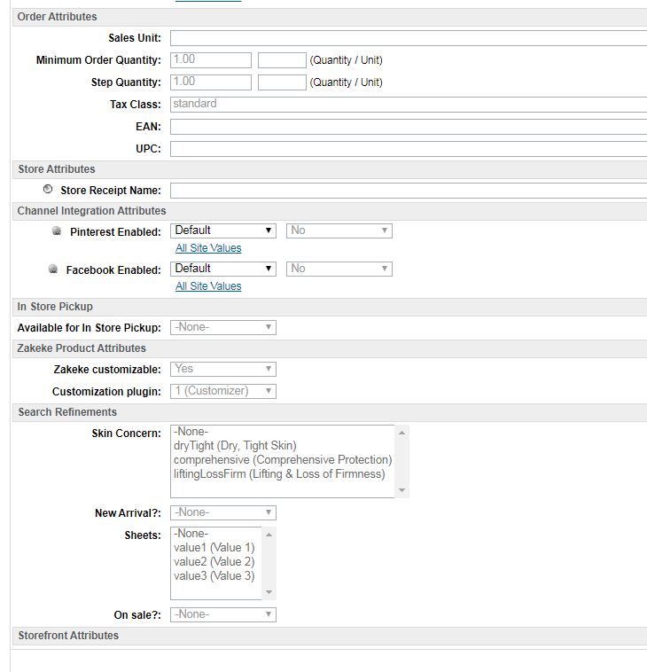

1. If you go to the web store and search the selected product, in the PDP (product detail page) a new button “Customize” should appear after the selection of variation options.

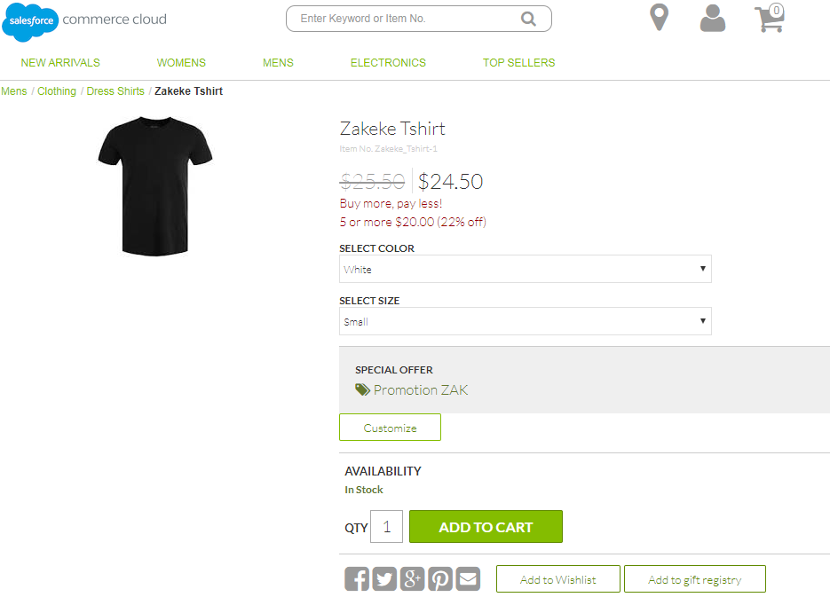

1. Clicking the “Customize button” you are redirected to a custom Zakeke page in which you can use Zakeke <iframe> to customize the product in a 3d environment.

See the image below.

1. If you used the “**customizer**” as type of plugin for the selected product, you’ll see the customizer page. See the image below.

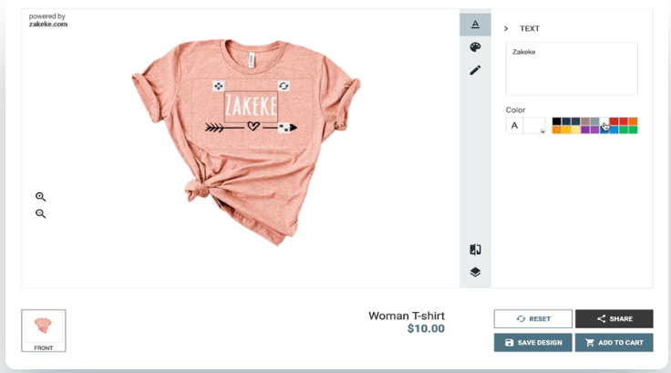

1. If you used the “**configurator**” as type of plugin for the selected product, you’ll see the configurator page. See the image below.

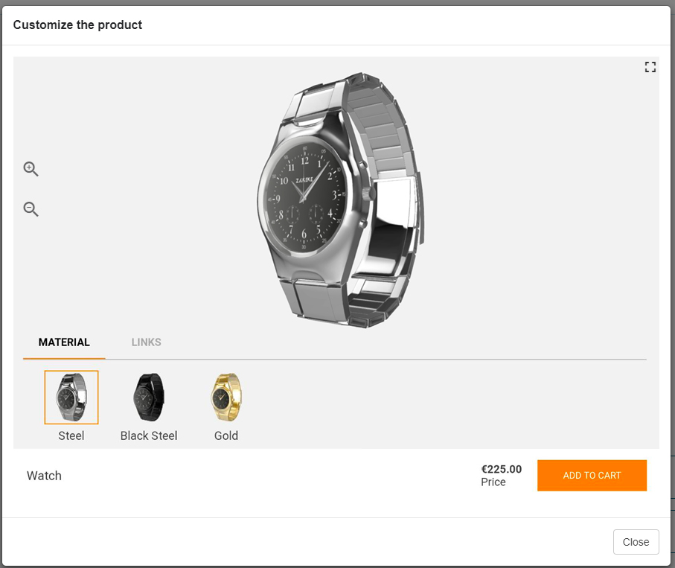

In the case of “Zakeke options” (configured into Zakeke Platform with custom prices) the selection of different attributes should modify the total price of the cart.

1. At the end of customization process, accept the options selected by clicking the “Add to cart” button.
2. The “Add to cart” action adds the selected item to the cart redirecting the customer to the cart page.

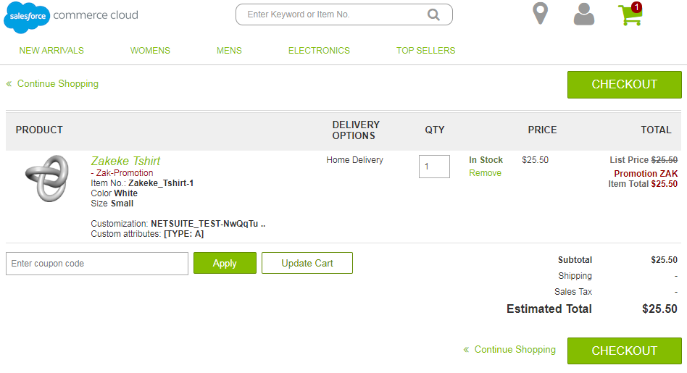

As you can see in the cart above, you should see a customized product image instead of the standard image of the item/variant selected.

1. Insert shipping information and payment information and place the order. The summary section of the cart in these pages should contain again customized product image instead of the standard image of the item/variant selected.
2. At the end of the order if you go to Business manager -> Merchant tools-> Orders, you can see the new order record. There are some additional fields that are added by Zakeke extension:
   1. **customizationID** (the Zakeke identification code for customization)
   2. **price** **adjustment** (if Zakeke options with custom prices have been added for the item)
   3. **customization detail** in the “Notes” section of the order

See the images below.

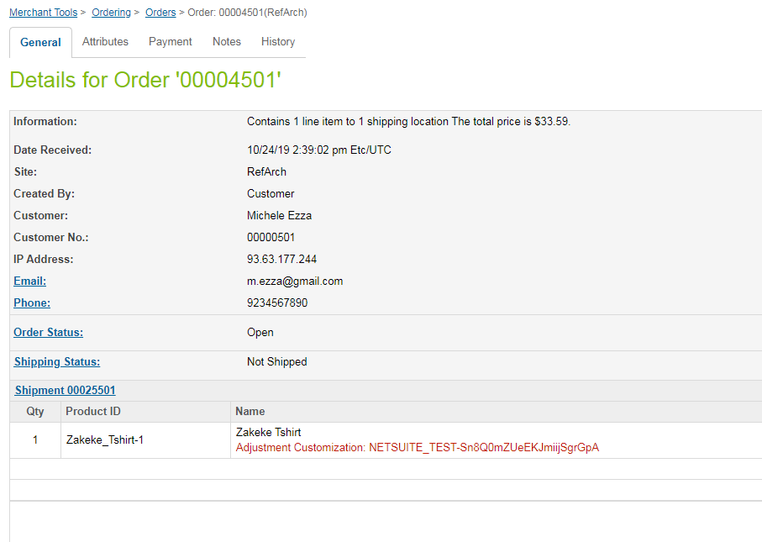

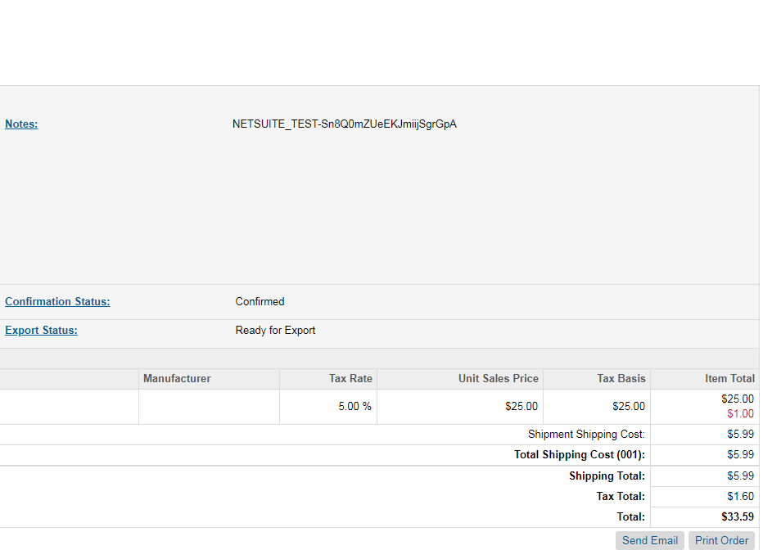

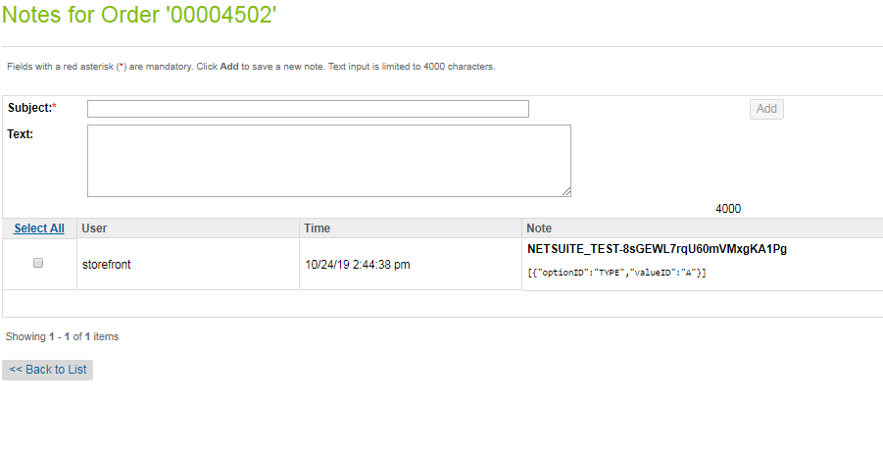

1. When a new order is created the extension generates a new record in the custom table **zakOrderNotifications**. If you go to Business manager -> Merchant tools-> Custom Objects -> Custom Object Editor, you can see a new record that has got the same **OrderID** of the just closed order. The new zakNotification record should have the status “**ADDED**”. See the images below.

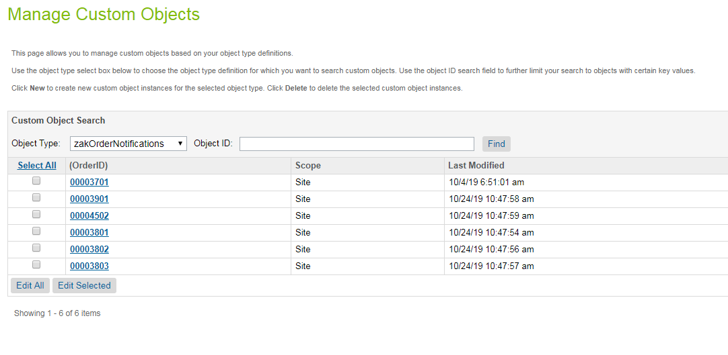

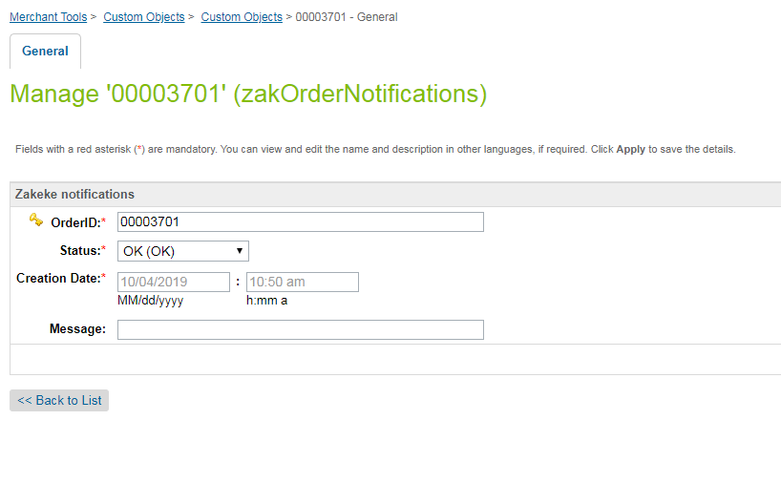

1. The aim of zakNotificationRecords is that of storing the status of the notification for each order. A custom job named “ZakekeNotification” is responsible for updating Zakeke platform about the successfully customized orders.
2. Go to Administrators->Operations->Jobs and open ZakekeNotification job and run the job. Go to “Schedule and History” section and click on button “Run now”.
3. When the job is finished, come back to zakNotificationRecord of the last order. The status of the record should be changed into “OK”. In this case it means that Zakeke platform has been notified and job closed correctly.
4. At the end you have to delete the notification record and cancel the order changing its status to “Cancelled”.